WEB DESIGN SCOPE DOCUMENT

Leonardo Christello
A00049165

Word Limit for Assignment: 1500 Actual Word Count: 1497

I confirm that this work is my own. I did not use generative AI to produce any part of it. All sources, stock images and participants are credited. - Leonardo Christello

2.1 AIMS AND OBJECTIVES

Client aims
Furry Friends wants to increase bookings for grooming and spa, dog training, and new Doggy Hotel. It also wants to increase brand awareness and attract more visitors to its social media channels.
The website should build trust by clearly presenting all services and prices, promoting the Doggy Hotel, displaying customer testimonials, and providing useful behaviour advice for dog and cat owners.

Measurable objectives
- Visitors should be able to access all services from the home page in one click.
- The website should display clear information and prices for all services.
- Every service page should offer a booking option.
- A visitor should be able to submit a booking enquiry in no more than three steps.
- The website should display at least three customer testimonials and ratings.
- The website should contain a "Pet Behaviour Tips" section.
- Links to Furry Friends' social media accounts should be visible in the website footer on every page.
- The contact page should include a form with fields for the visitor's name, email address, reason for contacting Furry Friends, and message.

2.2 COMPETITIVE ANALYSIS
Three Irish pet-care businesses were analysed: DSPCA Pet Hotel, The Pet Behaviour Centre, and Walkies Retreat.
Desktop screenshots:
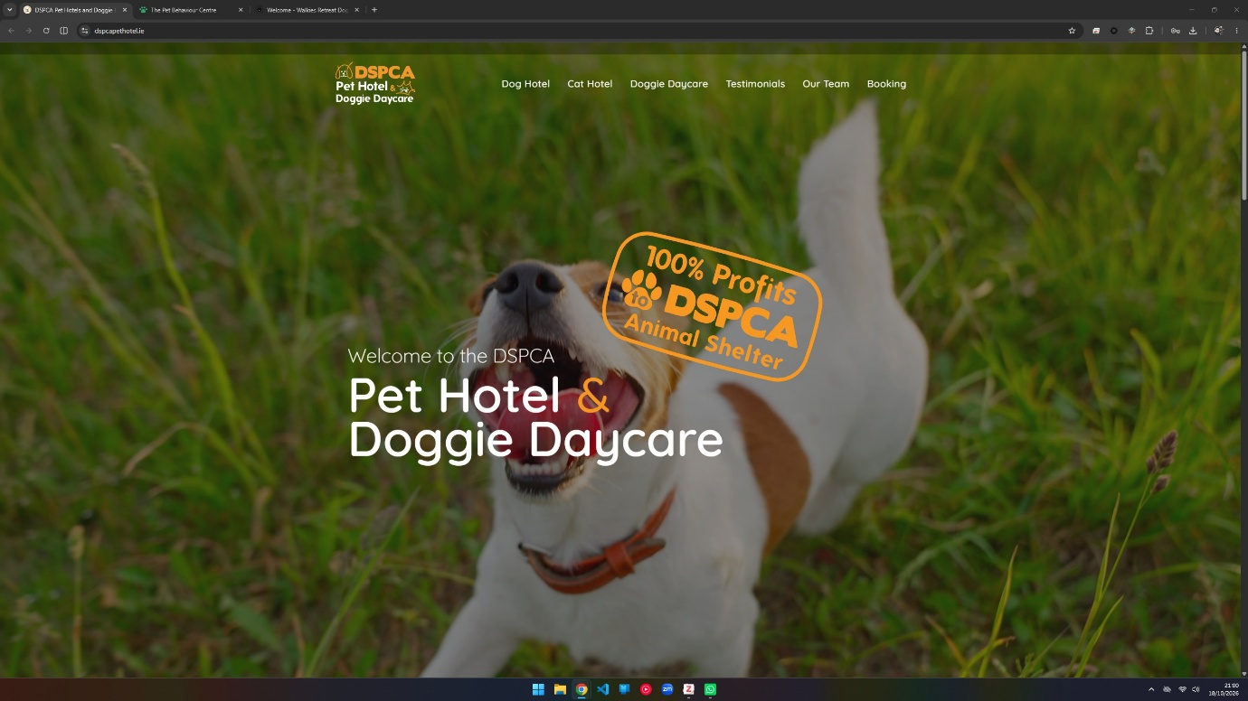
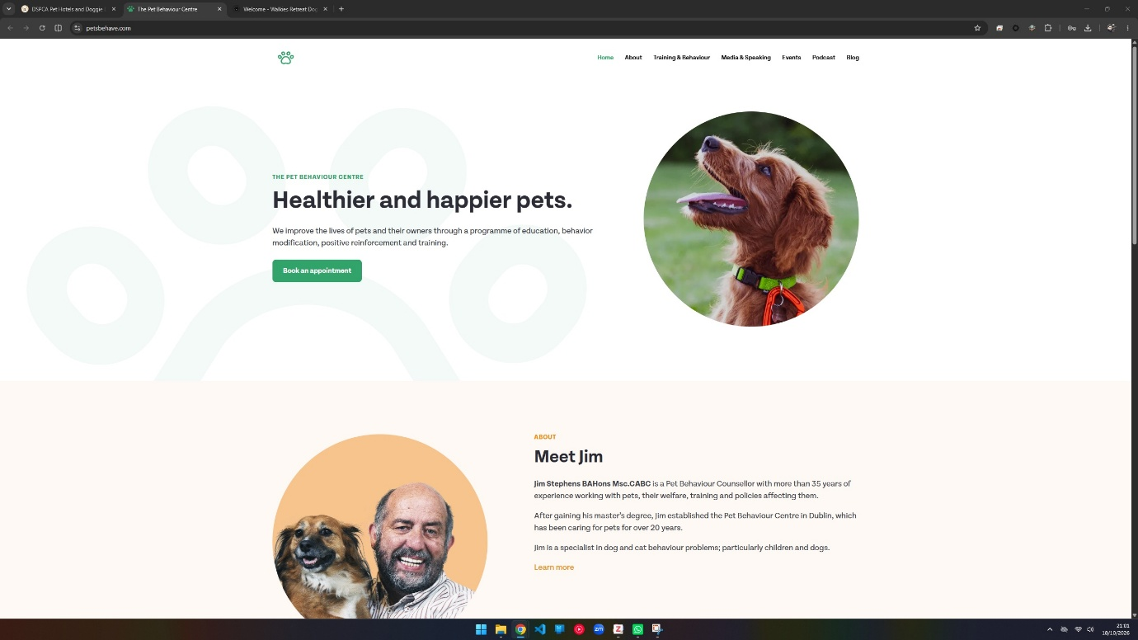
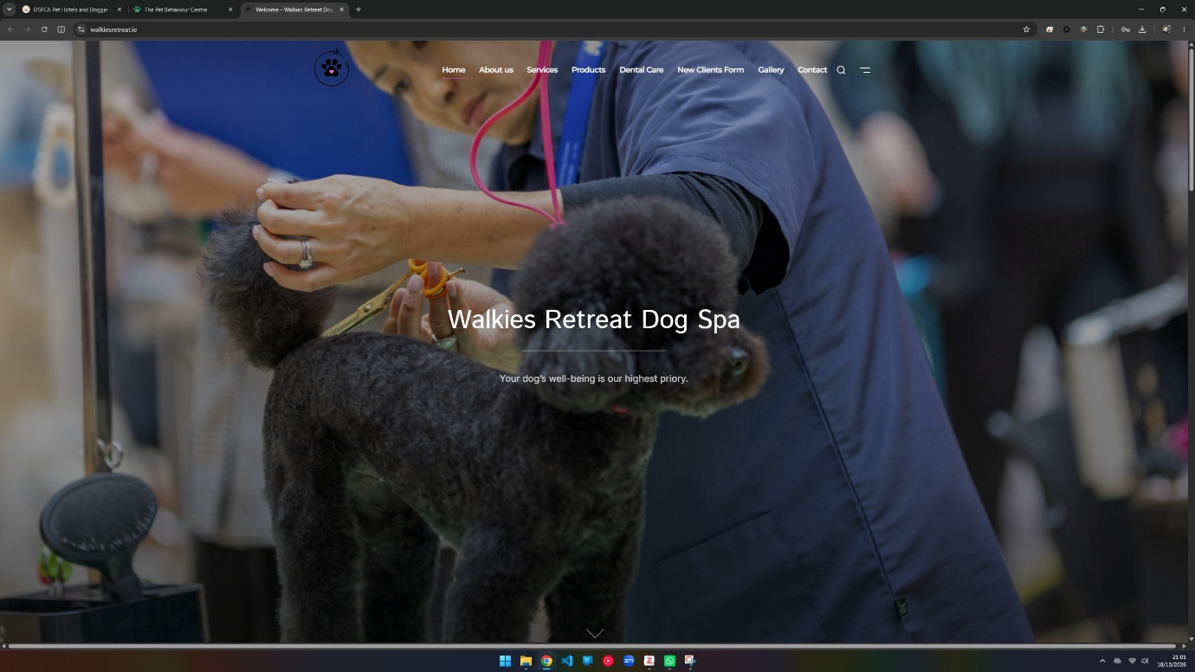

Mobile screenshots:
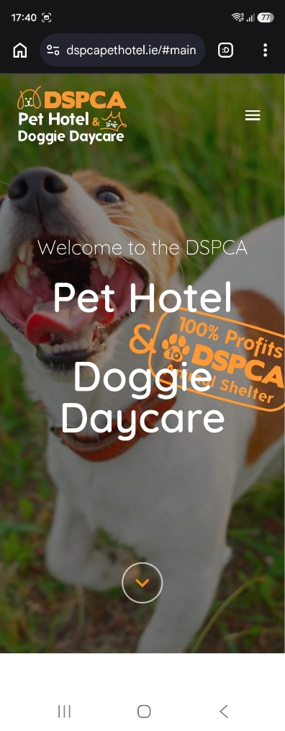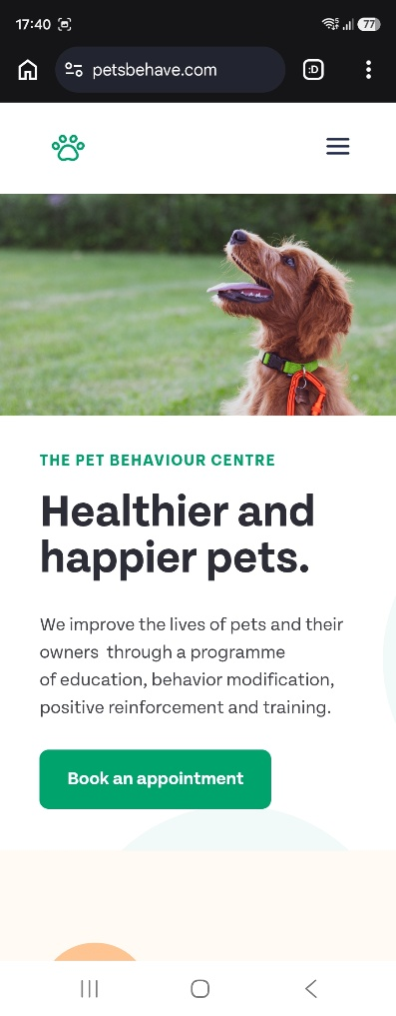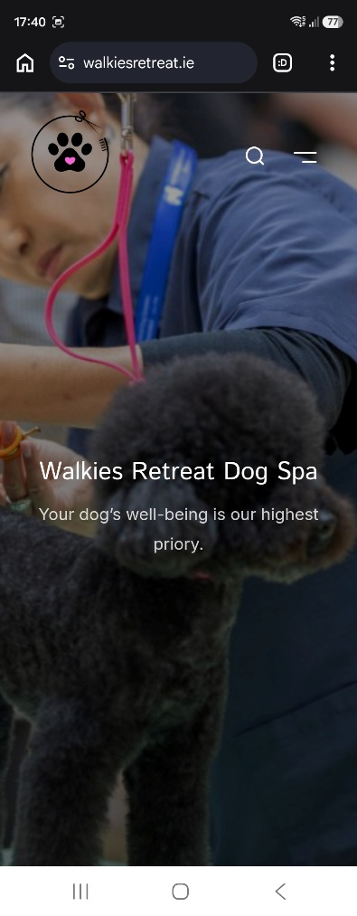

Business 1 – DSPCA Pet Hotel
Website: https://dspcapethotel.ie/
Location: Dublin.
Service: Dog Hotel – €42 per night.
Clicks: 36
- Visual design: The website uses a consistent orange accent colour, Quicksand sans-serif font and a similar navigation style throughout.
- Content design: It focuses on promoting its hotel and provides detailed information about how the business operates. Calls to action are generally clear.
- Technical features: The site is responsive, but some features need improvement. The testimonial gallery buttons do not always respond, and some navigation links lead to sections that are partially hidden behind the navbar.
- Overall effectiveness: Although online booking is available, the process is unnecessarily complicated, requiring 36 clicks and several repeated questions, making the experience frustrating.
Furry Friends should consider adopting the transparent pricing, detailed service information and attractive home page hero video showing dogs enjoying the facilities. However, it should avoid such a lengthy and repetitive booking process.

Business 2 – The Pet Behaviour Centre
Website: https://petsbehave.com/
Location: Dublin.
Service: Dog Training consultation – €200 for 120 minutes.
Clicks: 4
- Visual design: The website uses approximately ten colours but maintains a reasonably consistent appearance. It uses the Tenon sans-serif font and simple navigation, although the current page is not always highlighted on navigation bar.
- Content design: Information is presented clearly, starting with simple explanations and providing more details as visitors explore the website. Good spacing helps maintain a clean appearance.
- Technical features: The website is responsive and interactions work smoothly. However, the booking feature does not appear to work.
- Overall effectiveness: It communicates its services, experience and results effectively. Unfortunately, the prominent "Book an Appointment" button does not allow visitors to complete a booking, which significantly affects its usefulness.
Furry Friends should consider adopting the clean layout and effective use of spacing, while avoiding excessive colours and non-functional booking features. Virtual consultations could also be considered as an additional service for customers who cannot easily visit in person.

Business 3 – Walkies Retreat
Website: https://walkiesretreat.ie/
Location: Wicklow.
Service: Full Pamper – €70 for an average sized dog.
Clicks: 4
Booking form: 31 fields, 30 mandatory.
- Visual design: The welcome pop-up could be better styled, and the transparent navigation bar sometimes makes text difficult to read against the hero image. The website uses several fonts, including Montserrat, Inter, Istok and Onest. Calls to action are inconsistent in colour, borders and capitalisation.
- Content design: Extensive information, crowded navigation options and inconsistent presentation make it difficult to follow.
- Technical features: The website allows some unnecessary horizontal scrolling, even on desktop. Clicking the hero title refreshes the page without adding functionality. Form validation also appears insufficient, as mandatory first and last name fields accepted only whitespace.
- Overall effectiveness: Although visitors can find service prices and reach the booking form quickly, the complicated form and inconsistent design make the overall experience less user-friendly.
Furry Friends should avoid overcrowded navigation, inconsistent styling and unnecessarily complicated booking forms. The month selection using radio buttons and date selection using a slider were particularly confusing. However, the responsive "Back to Top" button was a useful feature worth considering.
Screenshot of month and date selection for reference: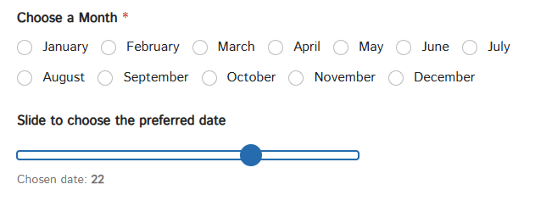

Overall Comparison
All three websites provide useful examples of what Furry Friends should consider when designing its own website. DSPCA demonstrates the importance of detailed service information and transparent pricing, while The Pet Behaviour Centre shows how effective a simple layout can be. Walkies Retreat highlights the problems caused by complicated forms and inconsistent design.
For Furry Friends, I would prioritise clear navigation, accessible pricing, consistent styling and a simple booking process that allows customers to complete their enquiries without unnecessary steps.

2.3 AUDIENCE RESEARCH AND PERSONAS
Persona 1 – María
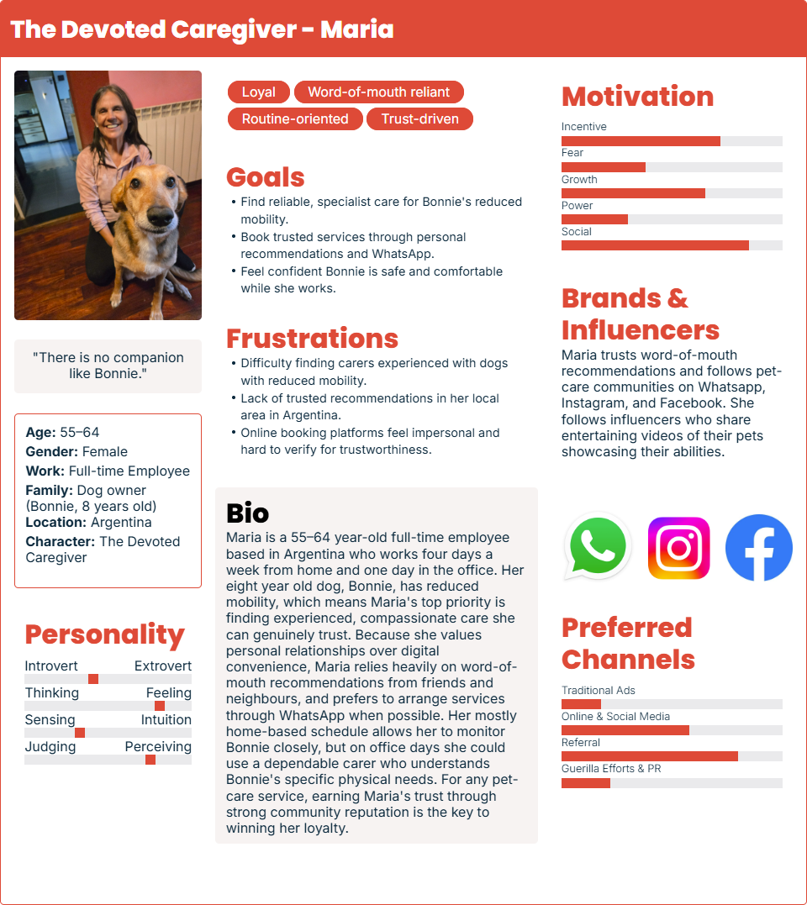
Persona 2 – Wenyang
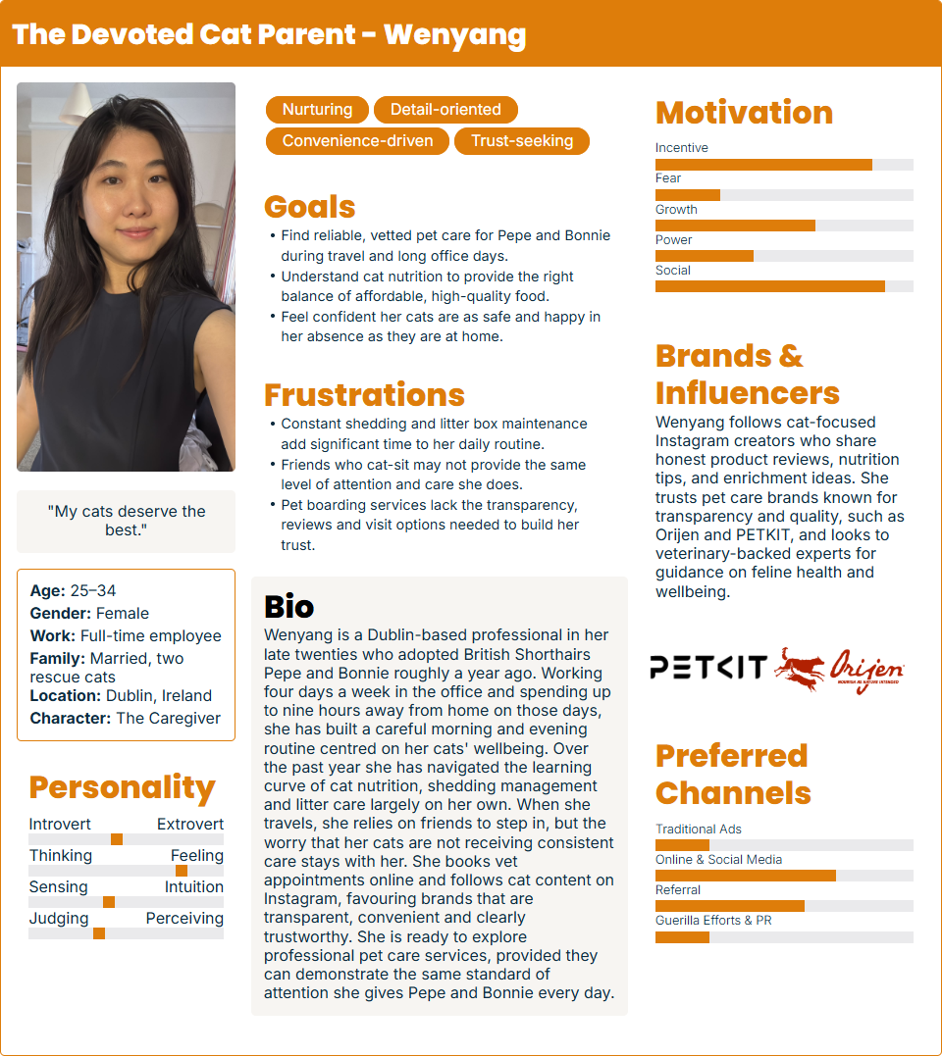

2.4 VISUAL DESIGN RESEARCH

Colours
I started by using Adobe's colour palette generator with photos I took myself of Maria's dog and Wenyang's cats. After comparing different palettes, I decided to use cream as the background colour to create a calm and welcoming atmosphere, leaf green as the primary brand colour to represent nature, and a more vibrant terracotta as the accent colour to add some playfulness.
For text, I chose a neutral charcoal to provide good readability and kept white as a secondary colour, mainly for accessibility purposes. Using Adobe's contrast checker, I found that terracotta (#E35336) with white text meets the WCAG AA contrast requirement for large text, but not the requirement for normal text. For this reason, I decided to use large, bold text on call-to-action buttons. I also considered a darker terracotta, but I felt it did not look as good with the rest of the palette.
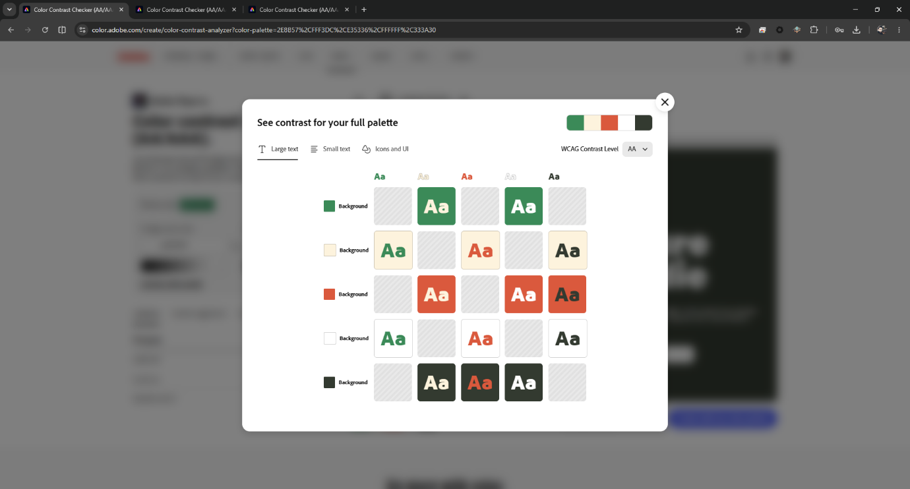
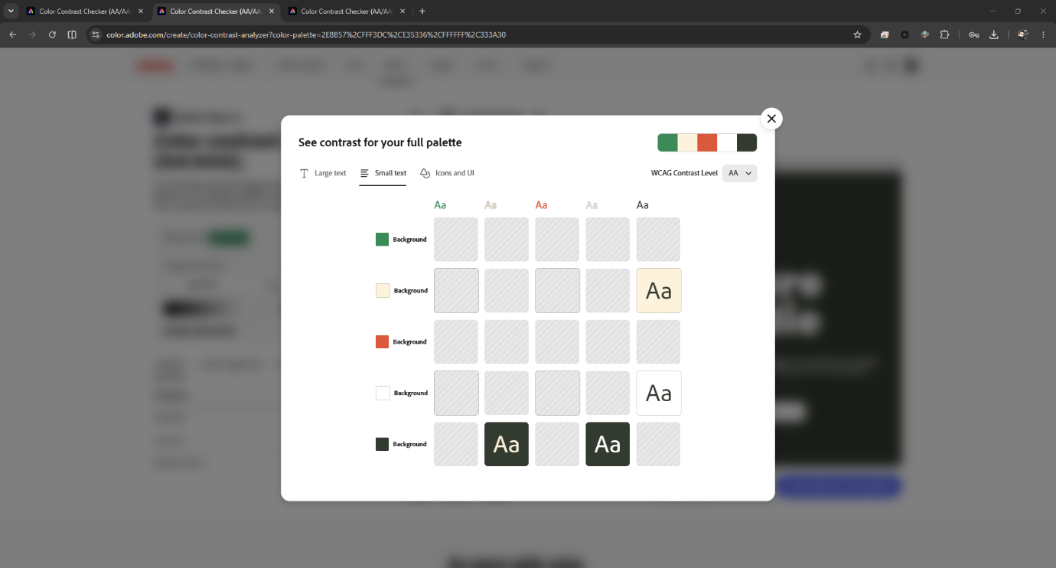

Typography
I initially explored Typescale to compare different fonts and establish a consistent type scale. However, since Arial was not available, I created a simple HTML page to better compare Arial with Nunito and Source Sans 3. I used Live Server and my PC's local IP address to access the page from my phone and take screenshots of each font.
I chose Nunito for headings because its rounded appearance gives the website a friendly and playful feeling, while Source Sans 3 provides a cleaner and more readable style for body text. I used a Minor Third scale (1.2 ratio) for consistency.
Simple code I wrote to compare fonts on phone:
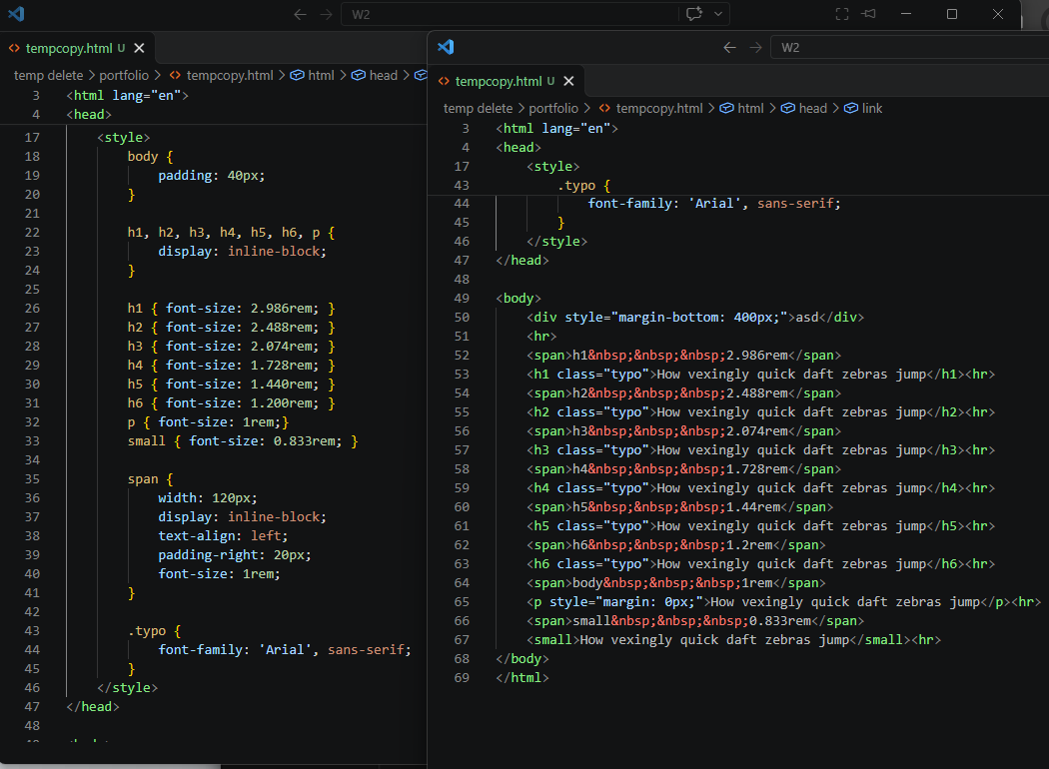
Nunito – Headers | Source Sans 3 – Body | Arial – For comparison
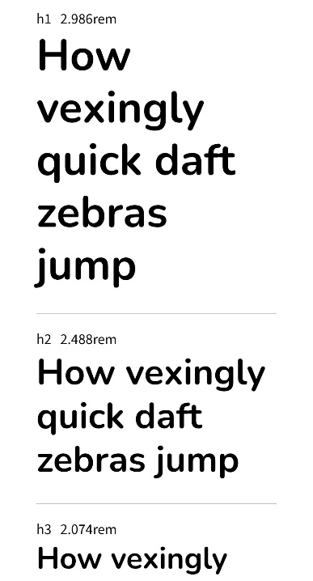 | 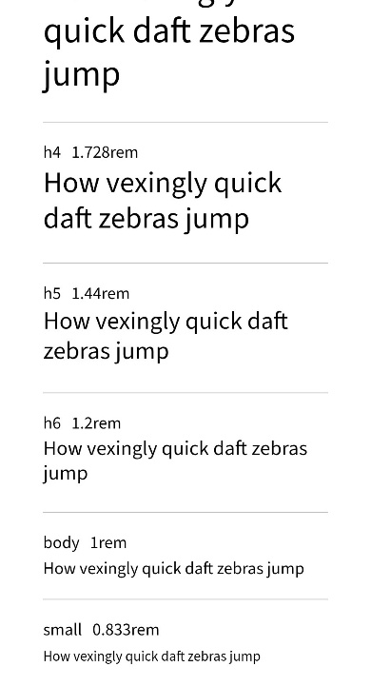 | 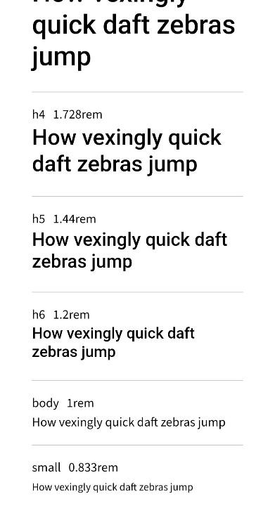

Mood board
After selecting the colours and typography, I put together the mood board. I also included the final colour palette and a screenshot of a simple HTML example showing how a heading, short paragraph and call-to-action button could look together. This helped me visualise how the colours and fonts would work together to create a warm and playful identity for Furry Friends.
https://app.milanote.com/1Xibv51IuRhhdD?p=h4CF2SrncSJ
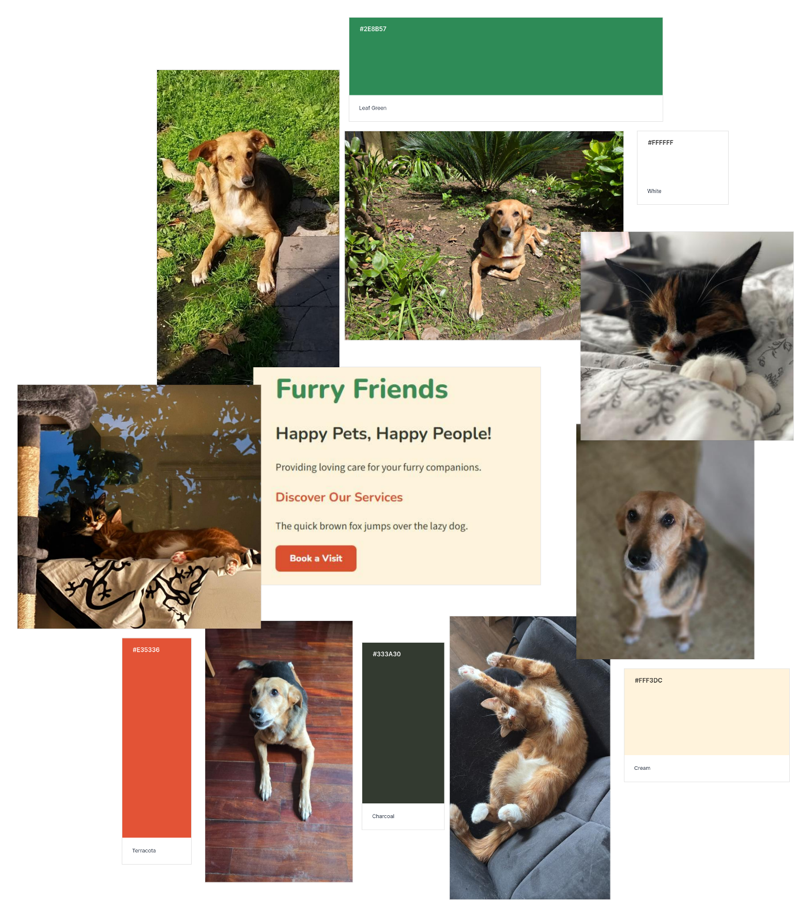

2.5 SKETCHES AND SITE MAP
We did not have the opportunity to draw these on the 22nd of October, but I sketched the layouts and drew the site map.

Sketches
Of the six sketches I designed, I decided to go with the first one. After completing the competitive analysis and comparing different websites, I felt that having a large hero image followed by a carousel or a row of images showcasing the services would be the best choice. Not only did the pet care websites I researched use similar layouts, but I also noticed this approach on popular hotel websites such as Hilton and Marriott. Although Furry Friends is a pet care business, I believe using a familiar layout could help visitors navigate the website more easily and quickly find the services they are interested in.
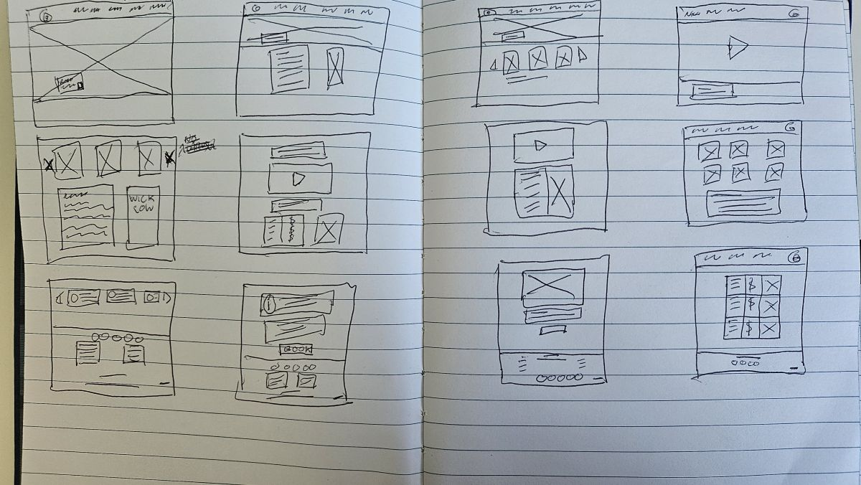

Site map
I initially considered having all services displayed individually in the navigation bar. However, I felt this would make the navigation too crowded, especially on mobile devices. For this reason, I decided to group all services under a single Services section. This allows visitors to access each service individually while keeping the main navigation cleaner and easier to use. I also decided to use a single Bookings page rather than separate booking pages for each service, to simplify the booking process. Regarding the Pet Behaviour Tips section, I haven't decided yet whether to make it a standalone page or include it within the Home page or another existing page. I'll make this decision when working on the wireframes, depending on which option fits the website layout better.
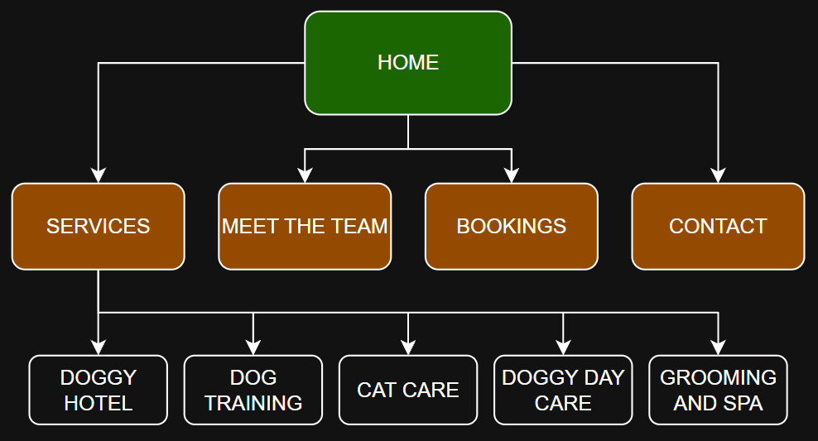

2.6 WIREFRAMES
All low-fidelity mock-ups can be viewed at: https://app.moqups.com/pO8k5m7nrdY0iUeHORR2XhbLX3dFcLFC/view/page/ad64222d5
Mobile Screenshots | Desktop Screenshots
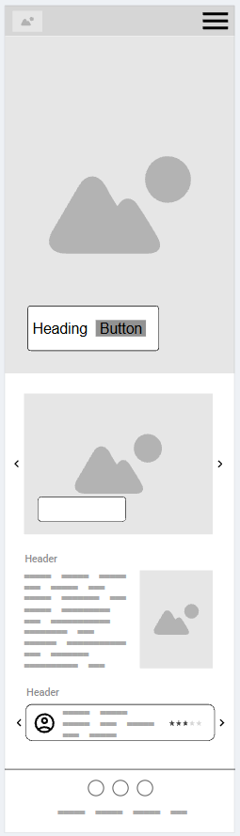 | 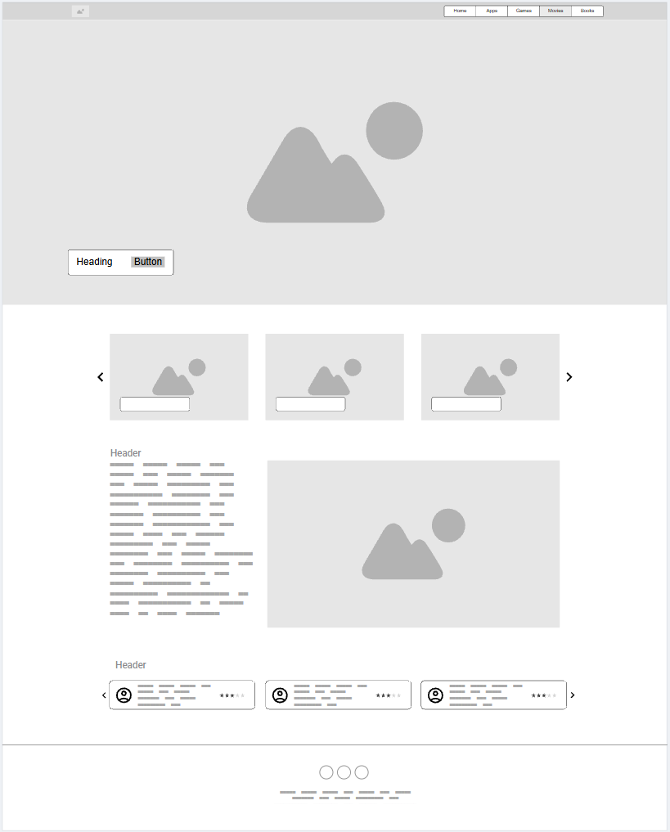
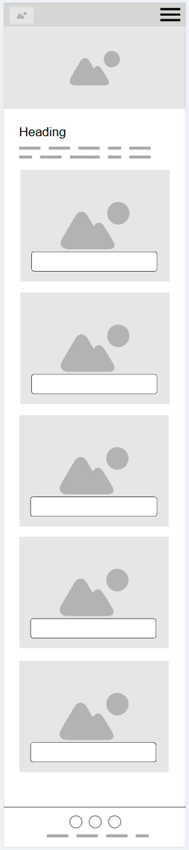 | 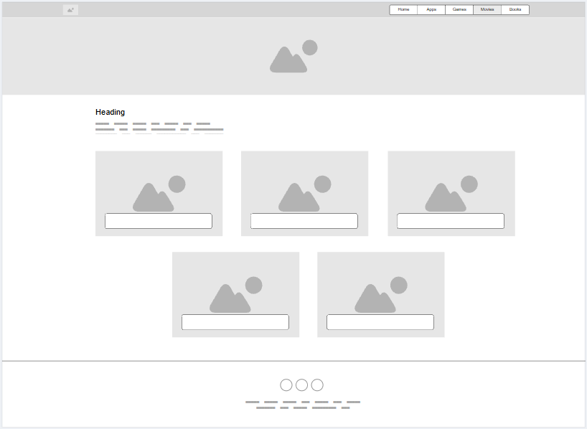
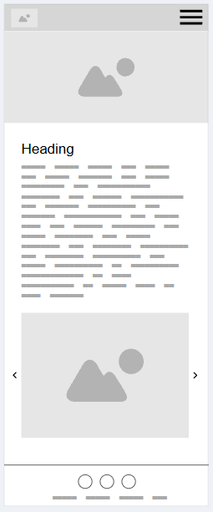 | 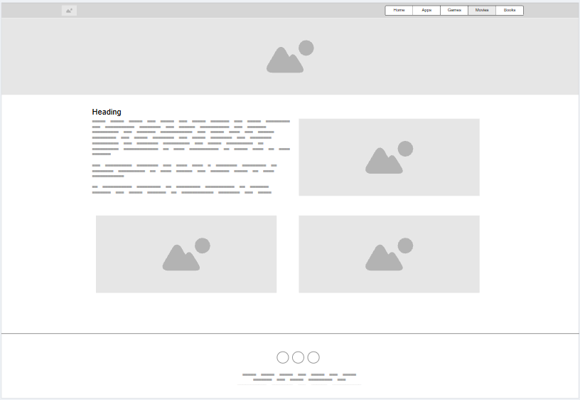

2.7 MOCK-UPS
High-fidelity desktop mock-ups: https://canva.link/d0fxek841tiekdy
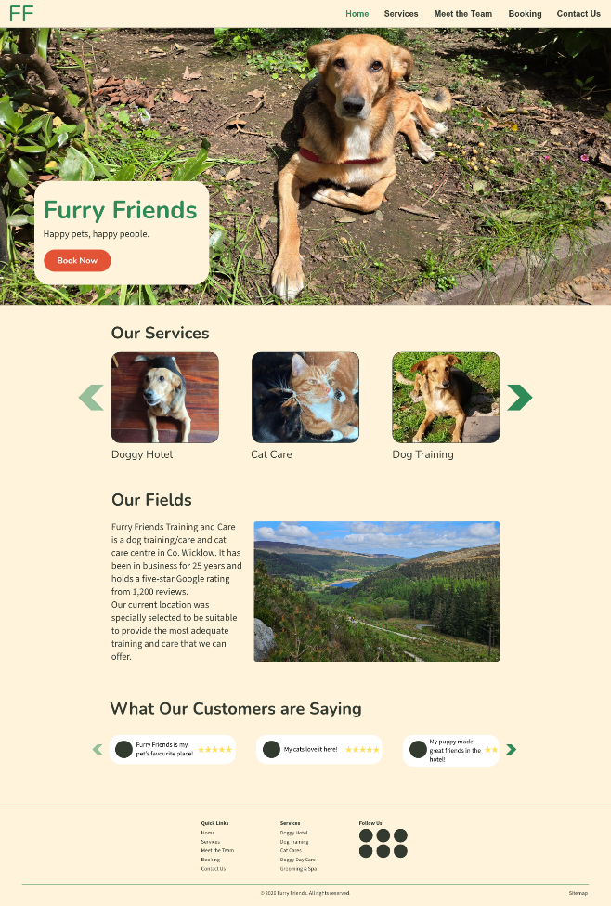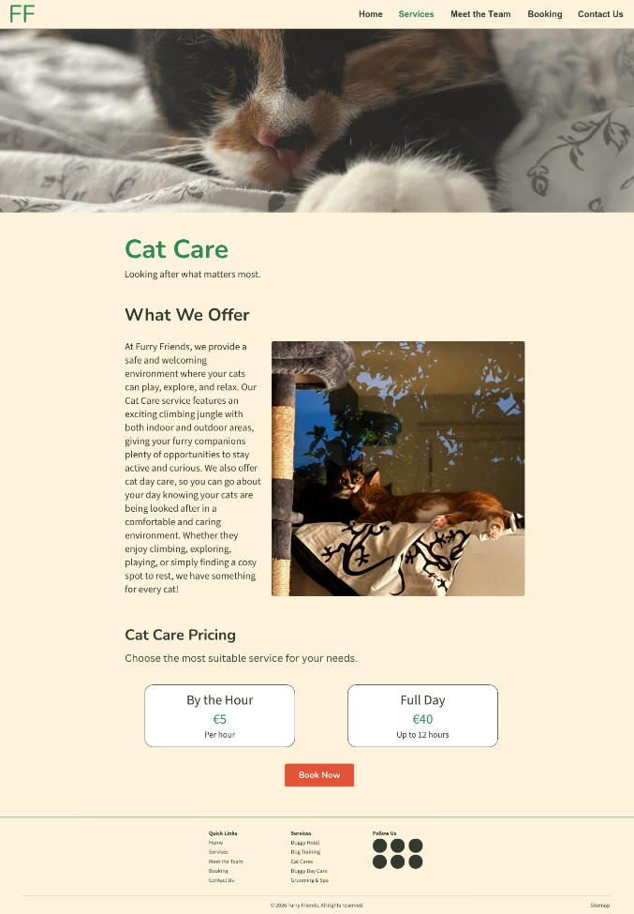
High-fidelity mobile mock-ups: https://canva.link/3hkh101khareaep
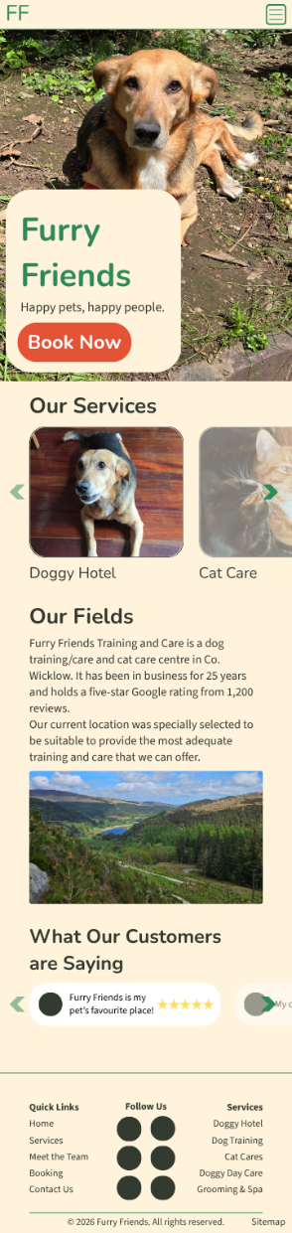 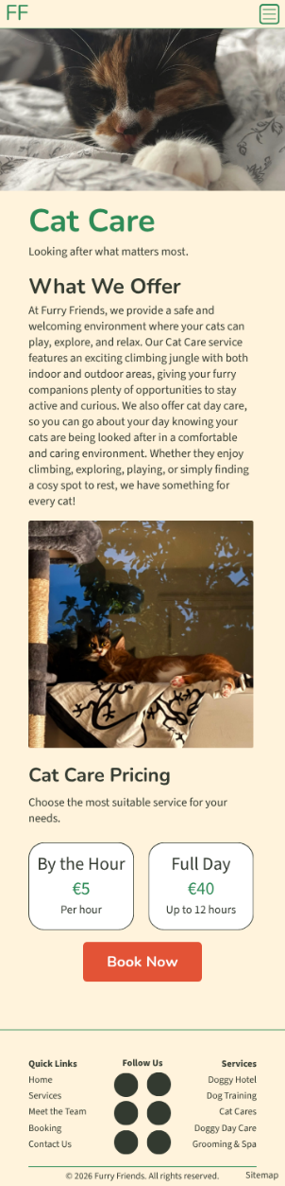
Version History: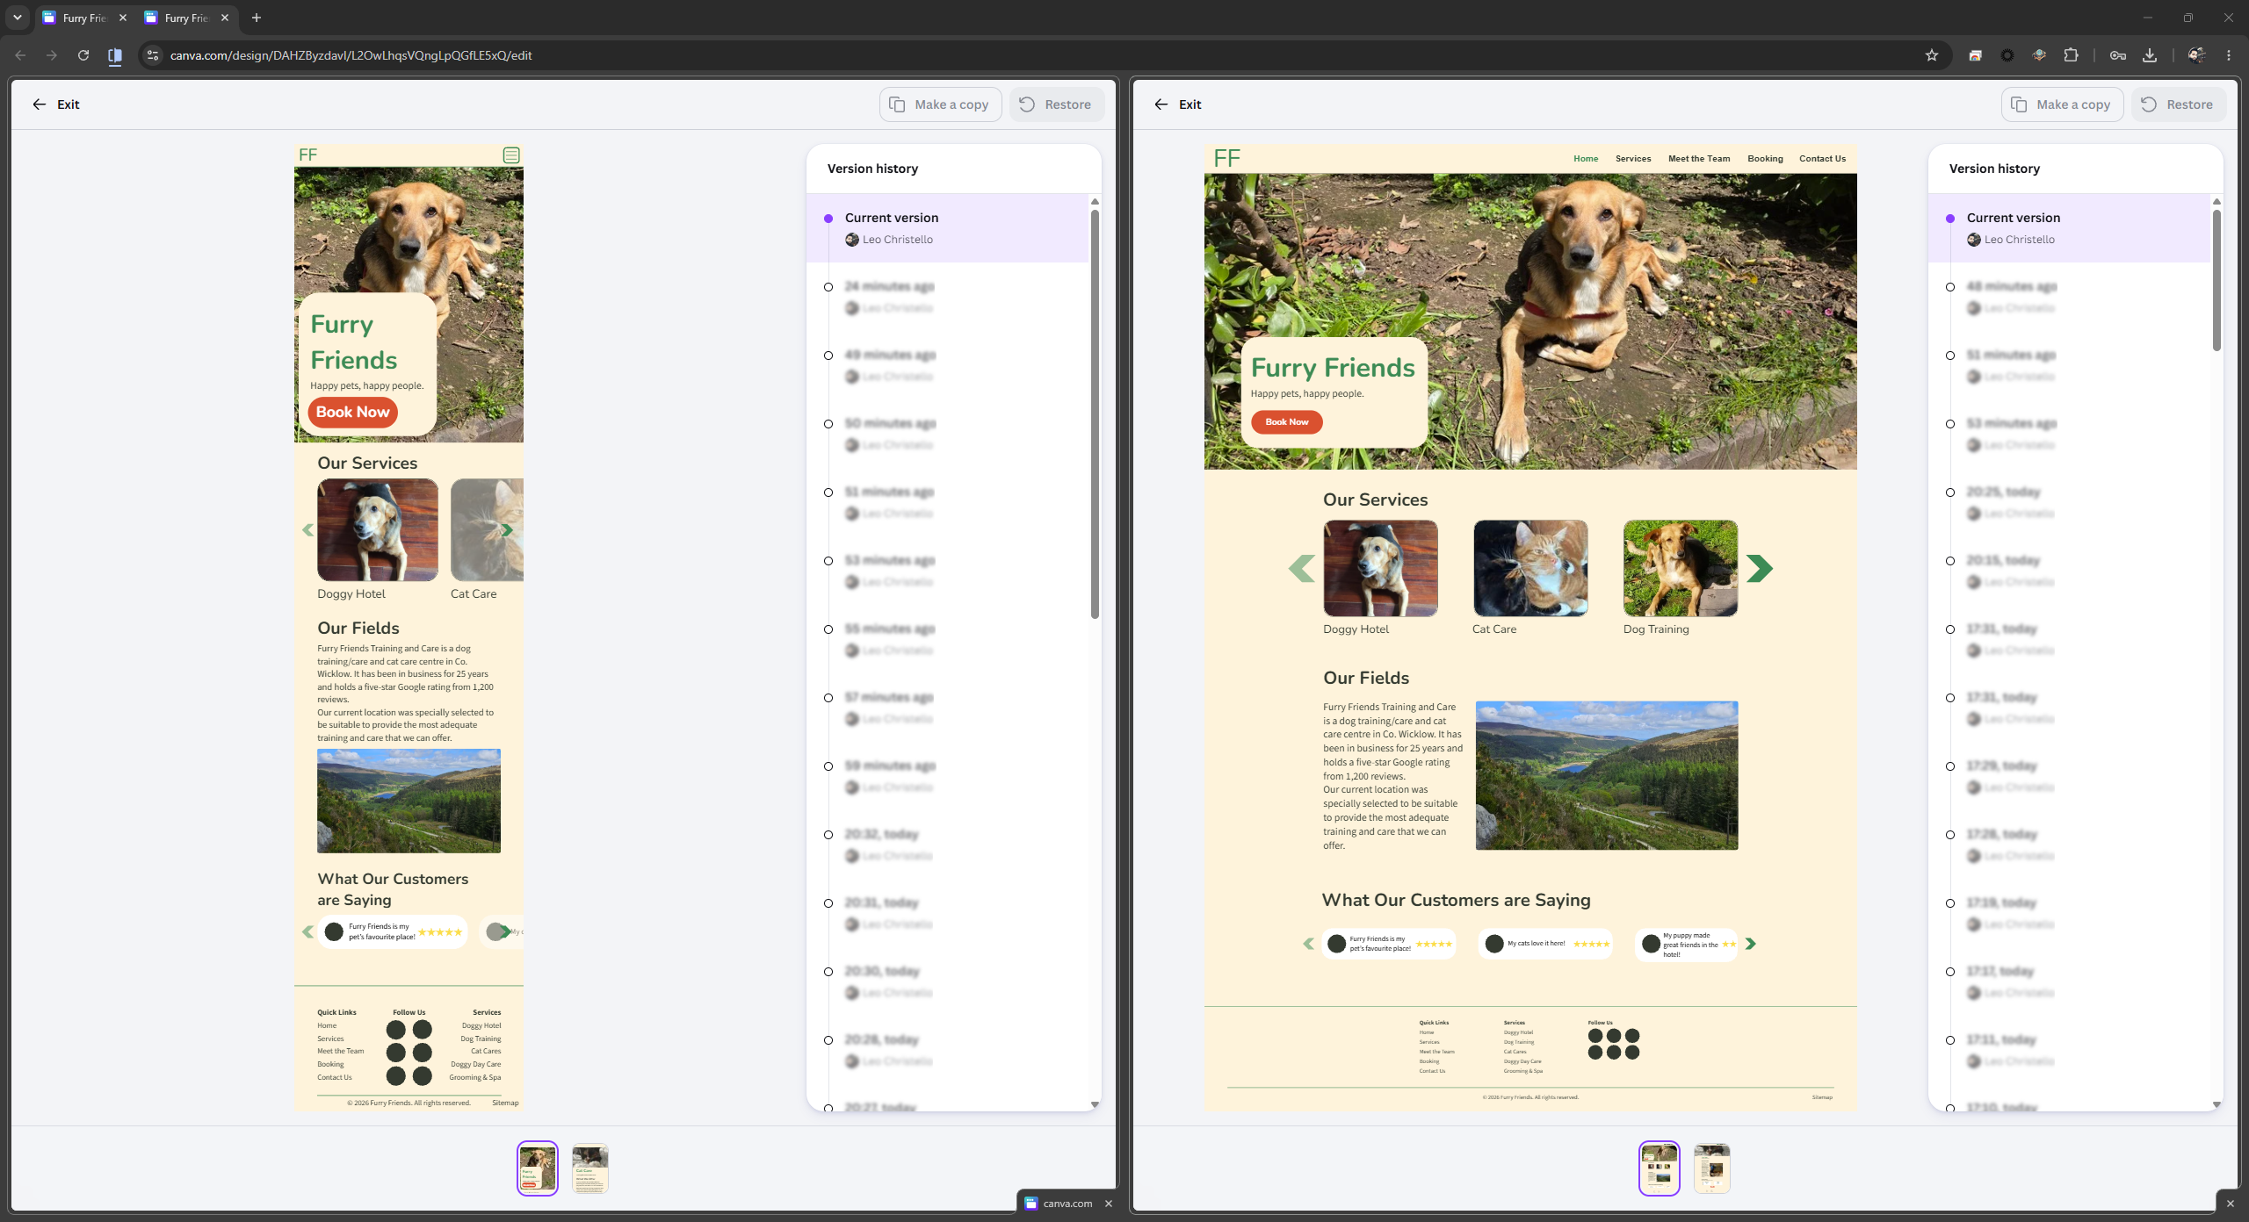

2.8 DESIGN DECISION LOG
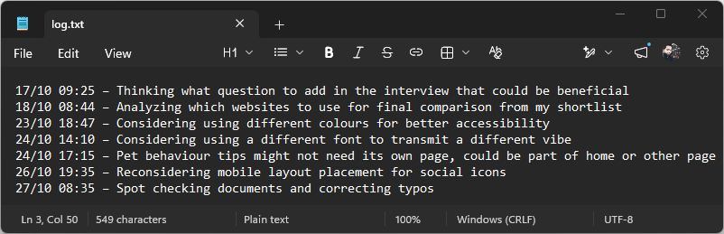
Further details can be viewed at: https://github.com/LeoChristello/TU054_Web_Social_Media/tree/main/Assignment

